creating table tab1:

create table tab1(

id1 int,

name1 varchar(10),

salary1 int

)

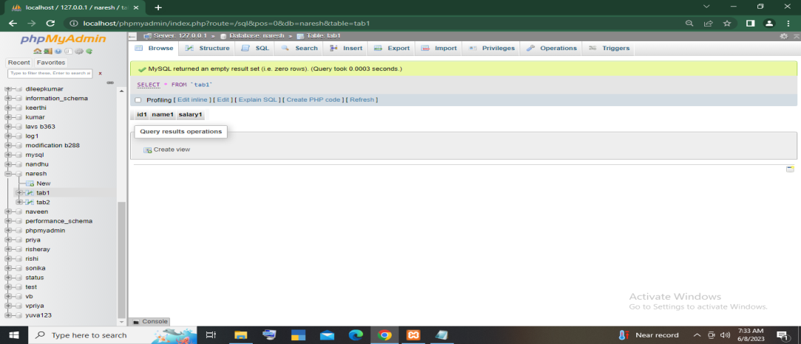

creating table tab2:

create table tab2(

id2 int,

name2 varchar(10),

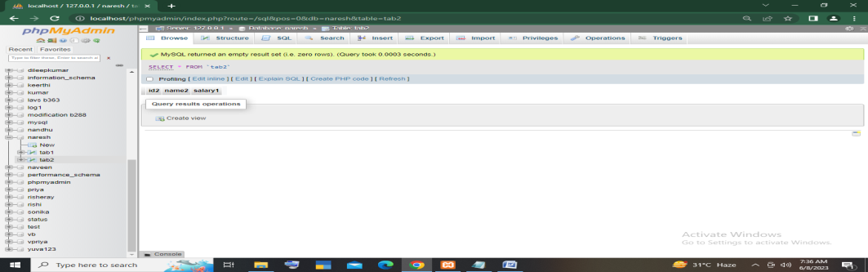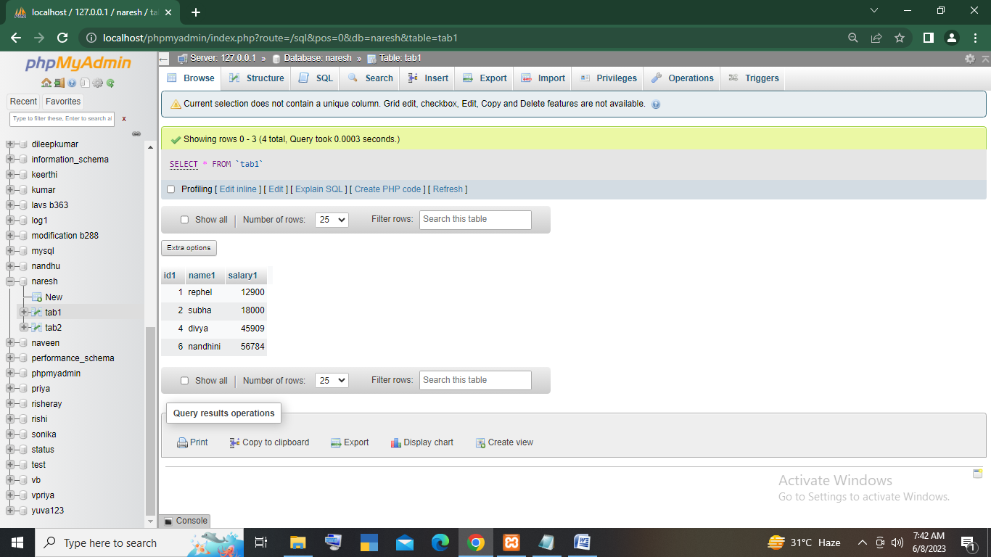salary1 int

)

Inserting the values in tab1 and tab2:

insert into tab1 values(1,"rephel",12900),(2,"subha",18000),(4,"divya",45909),

(6,"nandhini",56784)

insert into tab2 values(1,"rephel",12900),(2,"subha",18000),

(3,"nancy",45909),(5,"ram",56784)

inner join:

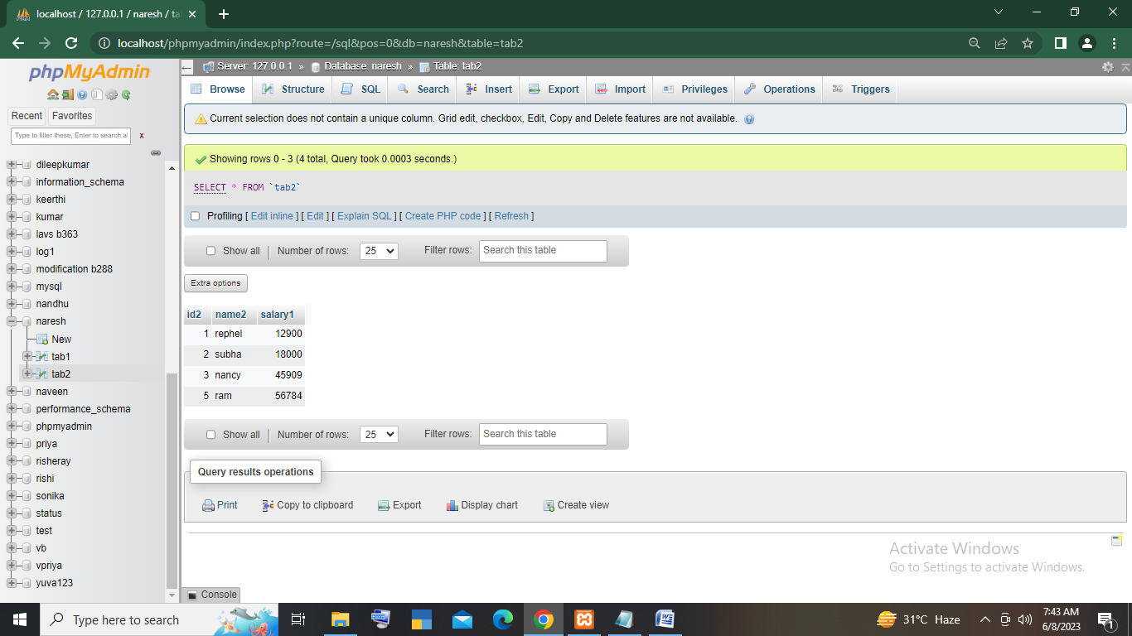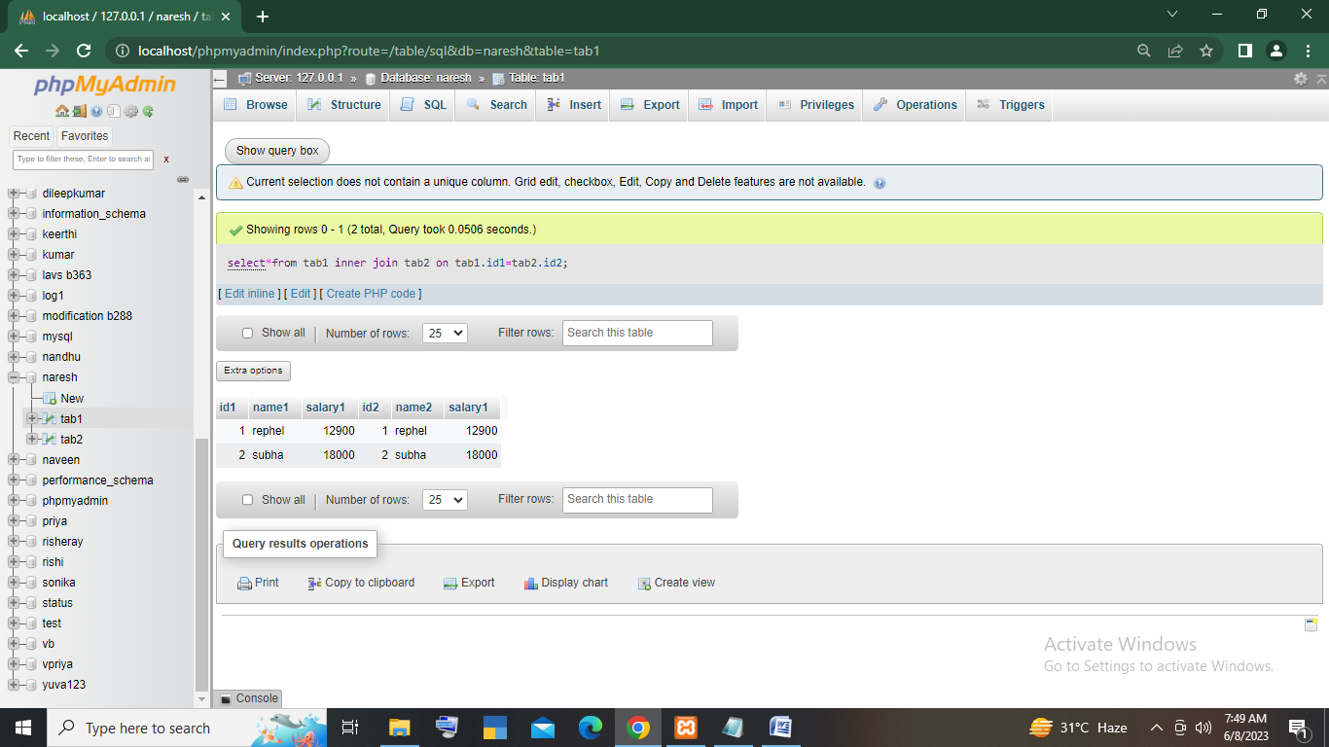select*from tab1 inner join tab2 on tab1.id1=tab2.id2

left join:

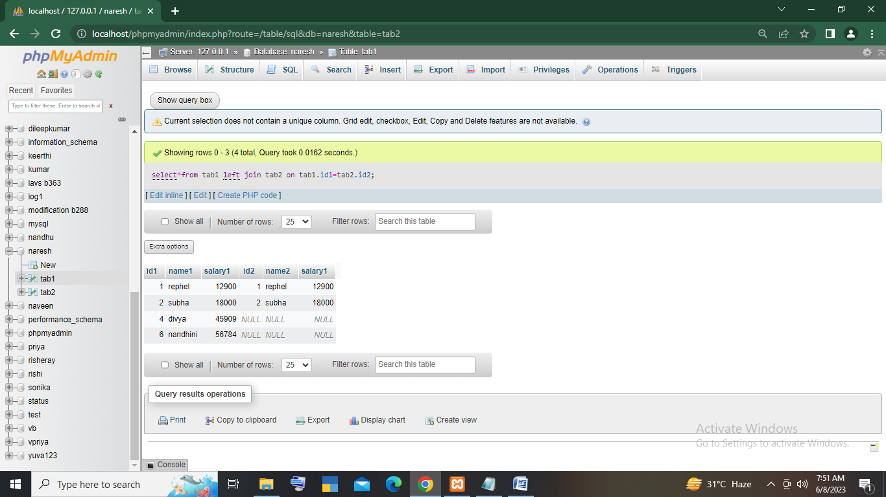select*from tab1 left join tab2 on tab1.id1=tab2.id2

right join:

select*from tab1 right join tab2 on tab1.id1=tab2.id2

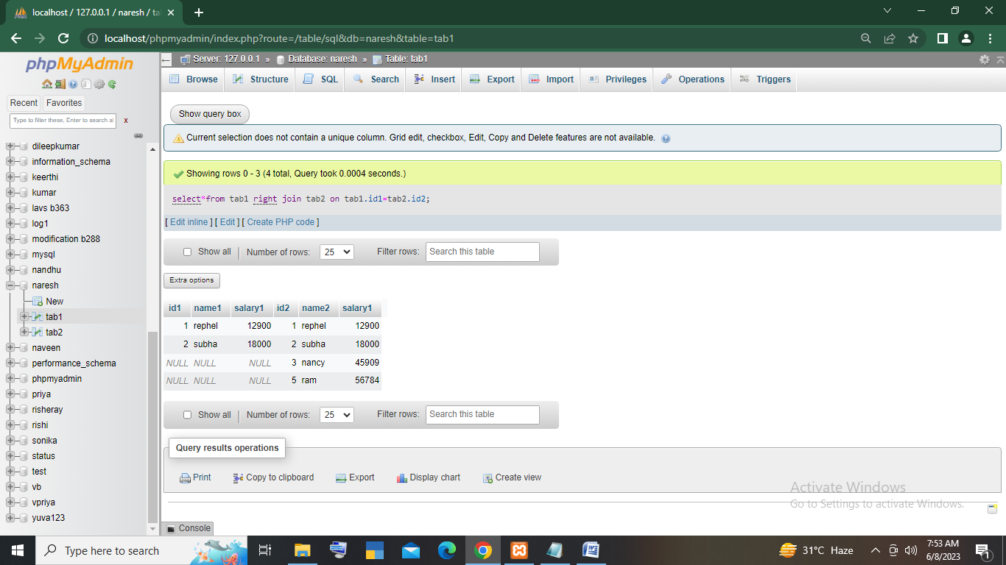

select*from tab1 right join tab2 on tab1.id1=tab2.id2

using aliases:

select t1.id1,t2.id2 from tab1 as t1 right join tab2 as t2 on t1.id1=t2.id2

create table tab3(color varchar(20))

create table tab4(size varchar(20))

insert into tab3 values("red"),("blue")

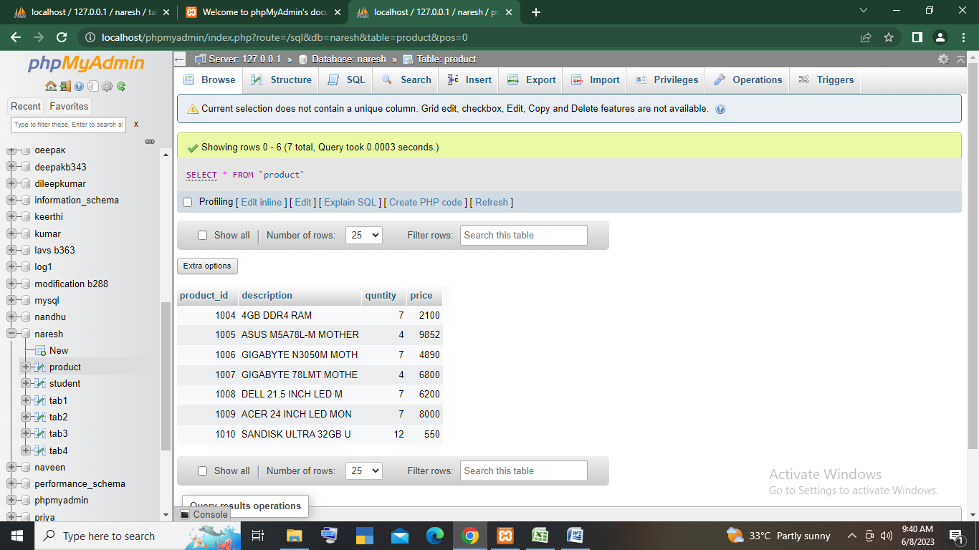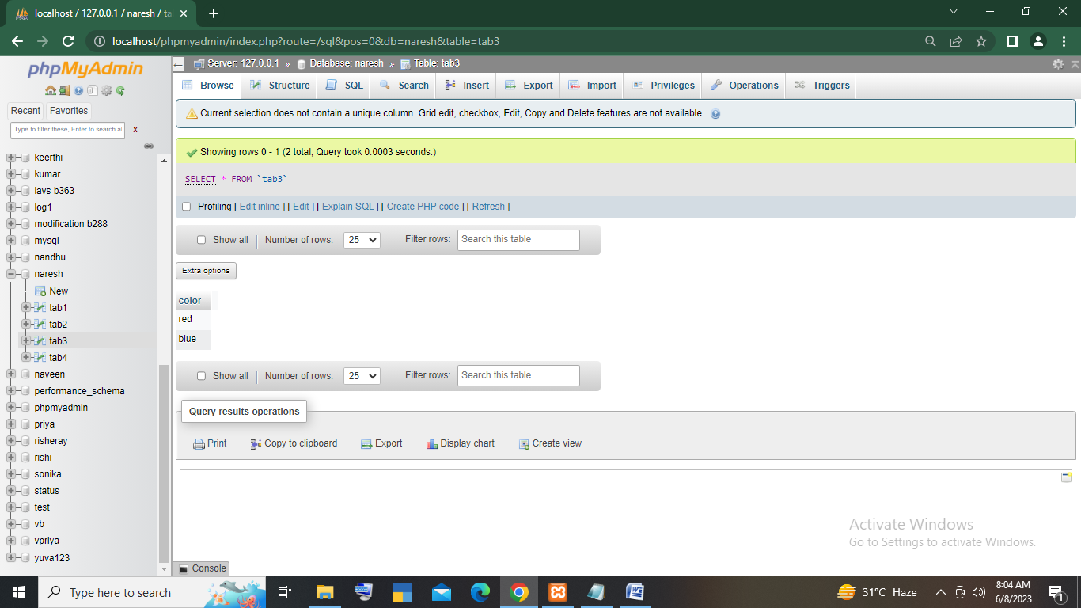insert into tab4 values("small"),("medium"),("large"),("extra large")

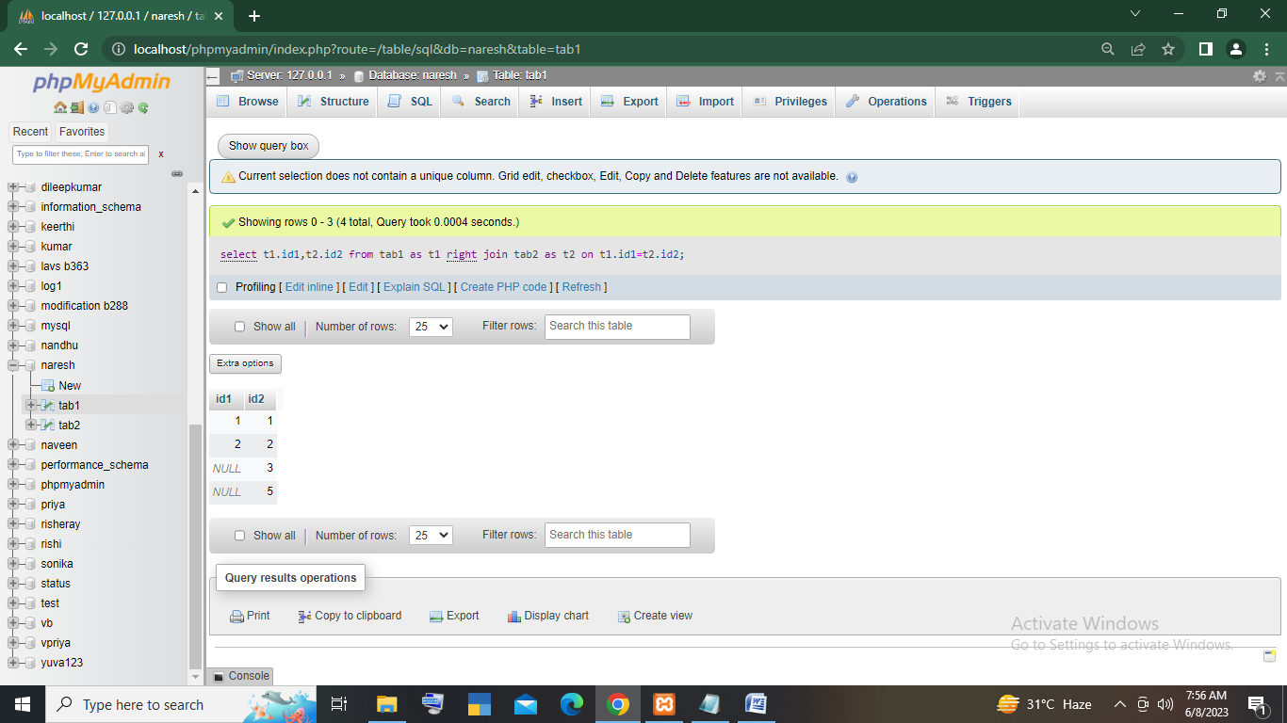

cross join:

select*from tab3 cross join tab4

ADDING 2 OF QUNTITY

UPDATE product SET quntity = quntity + 2

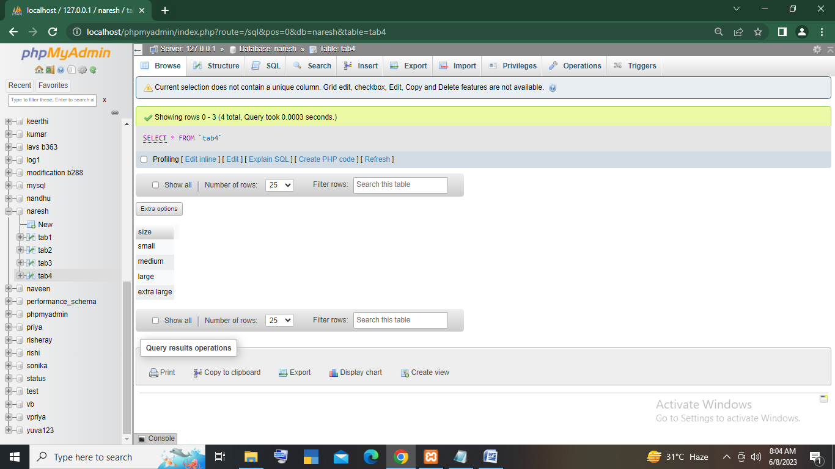

***Input:***

create table student(

enroll_no int,

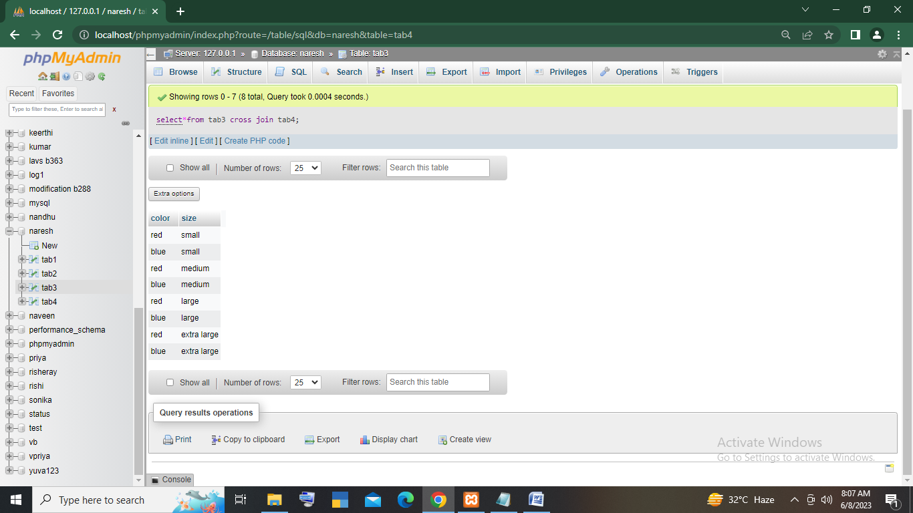student_name varchar(20),

gender varchar(2),

course varchar(10),

total_fees int

)

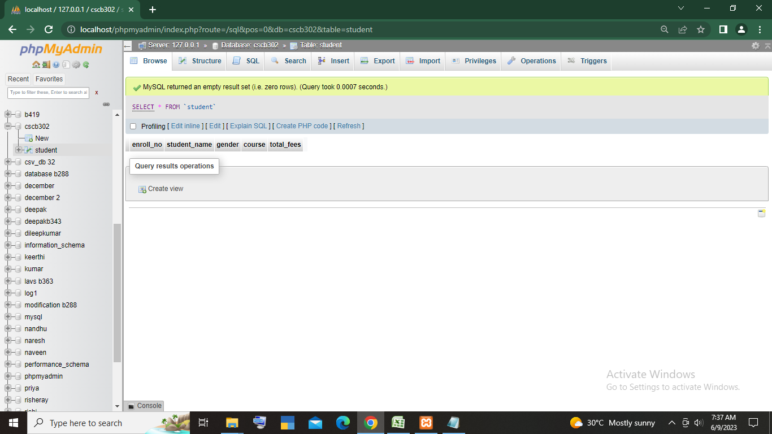Output:

***Input:***

***create table products(***

***product_id int,***

***description varchar(30),***

***quantity int,***

***price int***

***)***

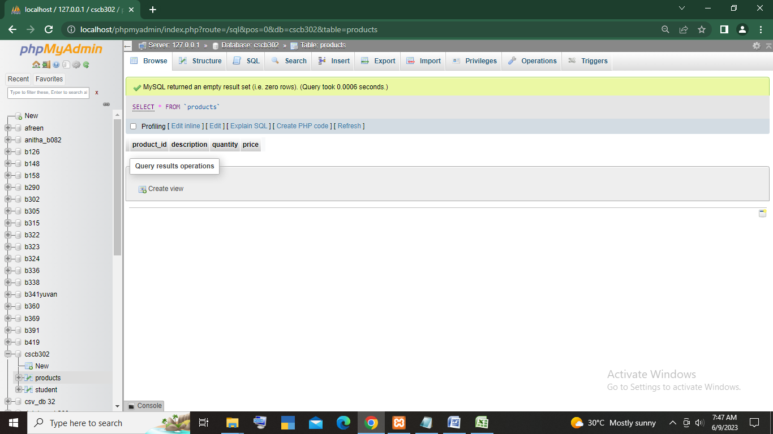***Output:***

***Impoting the values in table products:***

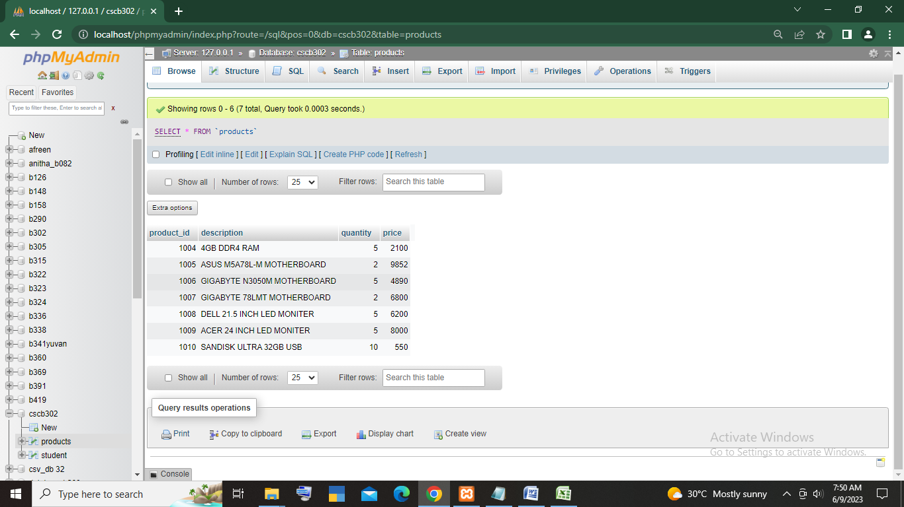

***Inserting the values in table student:***

***Insert into student values***

***(12014,”ram kumar”,”M”,”DCA”,8400),***

***(12015,”DAISY”,”F”,”HDCA”,14800),(12016,”KEERTHI”,”F”,”DCA”,9000),(12017,”MUKESH”,”M”,”HDCA”,14500),***

***(12018,”ANANYA”,”F”,”HDCA”,14800),(12019,”KARAN”,”M”,***

***“DCA”,9000),(12020,”MARTIN THOMAS”,”M”,”DCA”,8000)***

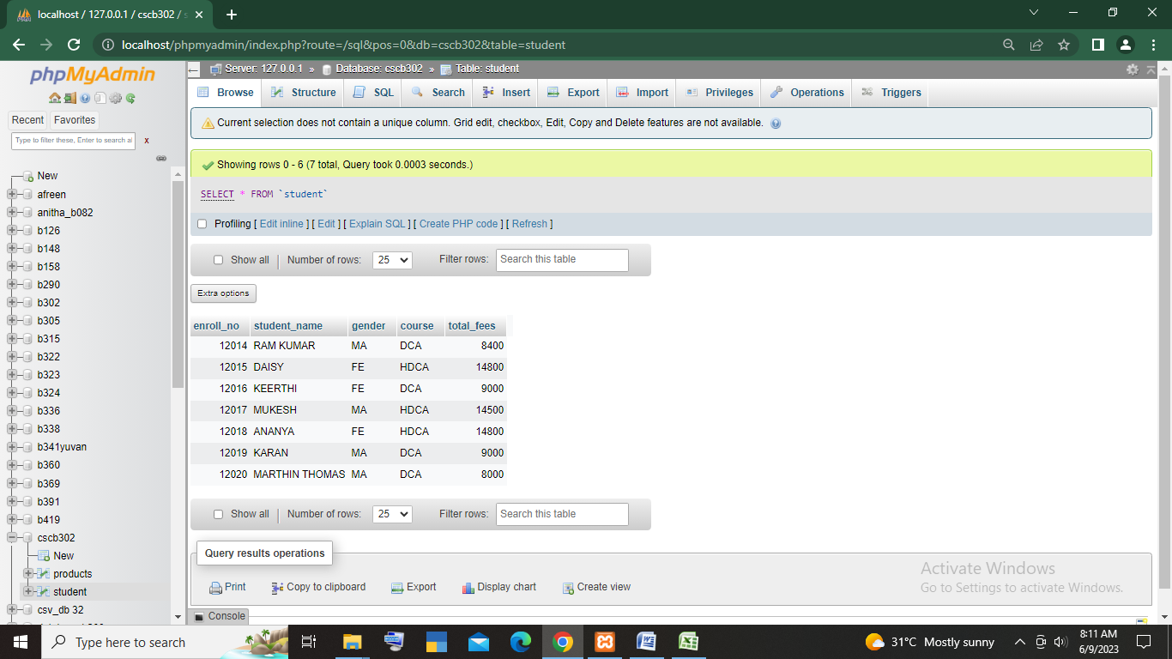***OUTPUT:***

***QUESTIONS:***

***1.ADD ALL QUANTITY WITH 2 FOR ALL THE PRODUCTS?***

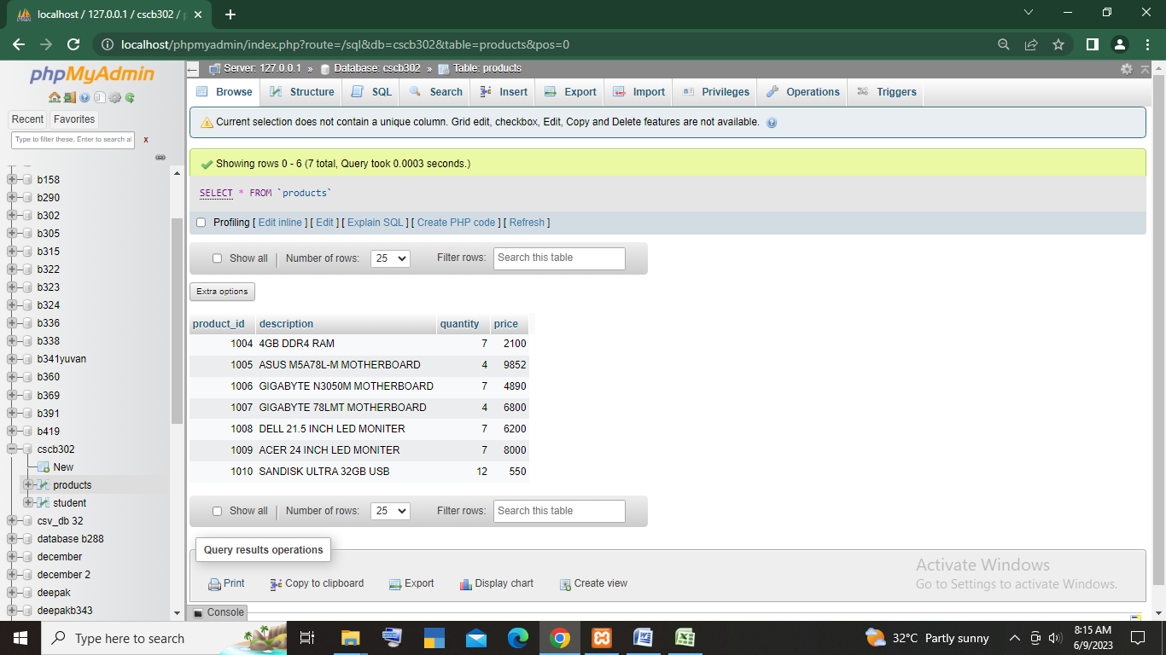***ANS: UPDATE PRODUCTS SET quantity=quantity + 2***

***2.subtract 2nos. from quantity for products greater than 3000?***

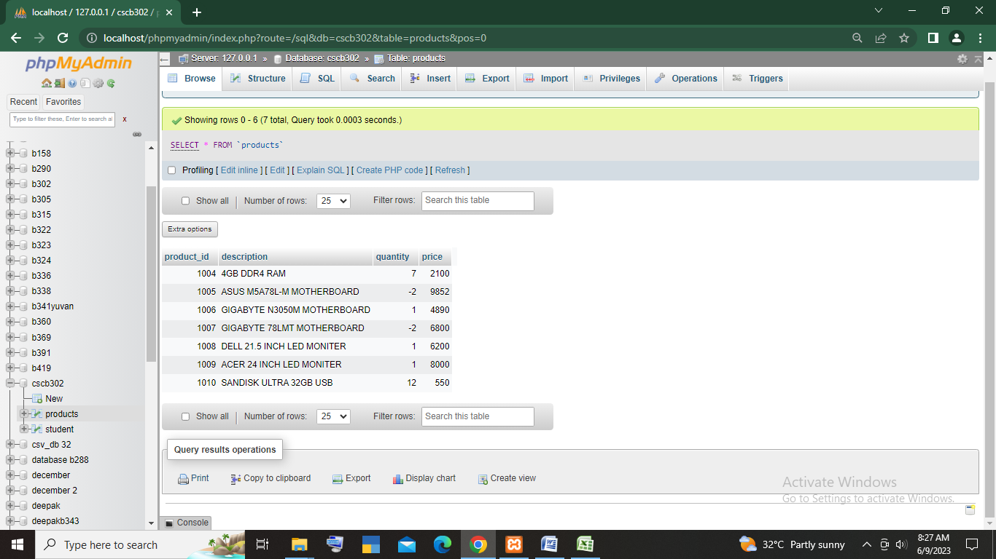***Ans: update products set quantity = quantity - 2 where price > 3000***

***3.increase the price by 5% for all the products whose quantity less than 5?***

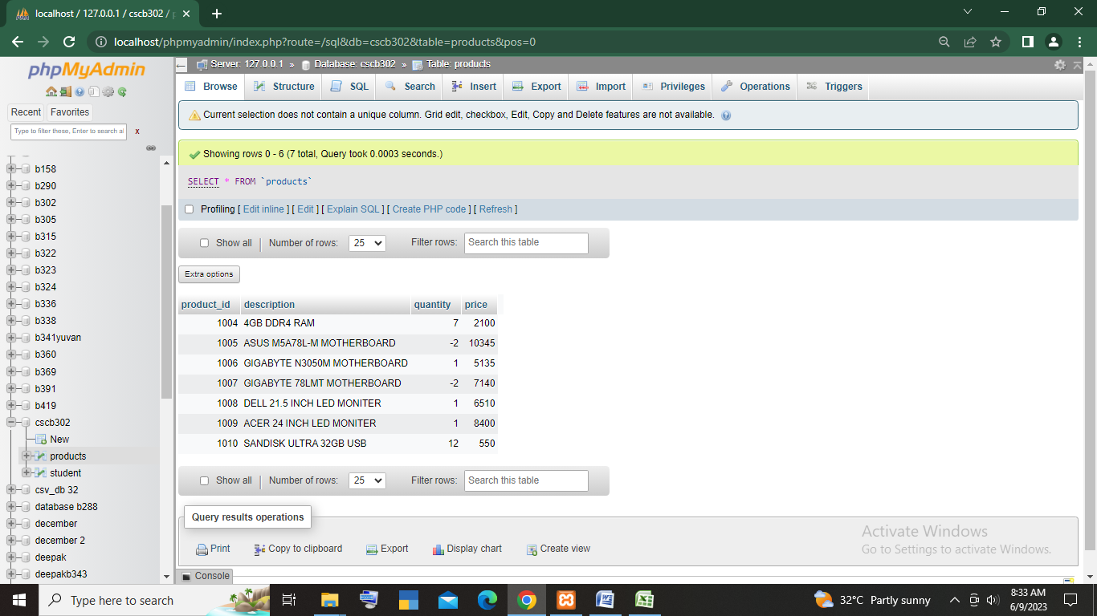***Ans: update products set price = price + (price*0.05) where quantity < 5***

***4.change the course by ADJP and fees by 9500 for the student MARTIN THOMAS?***

***ANS: update student set course = ‘ADJP’ and total_fees = 9500***

***Where student_name = ‘MARTIN THOMAS’***

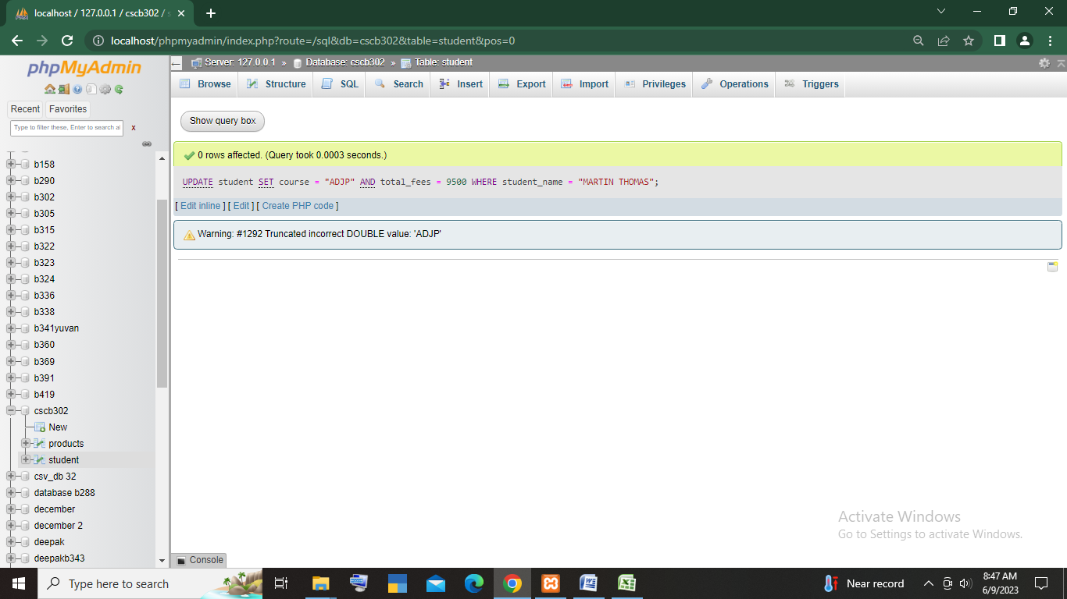

***5.CHANGE NAME OF THE STUDENT TO SNEKHA FOR THE STUDENT ID 12015?***

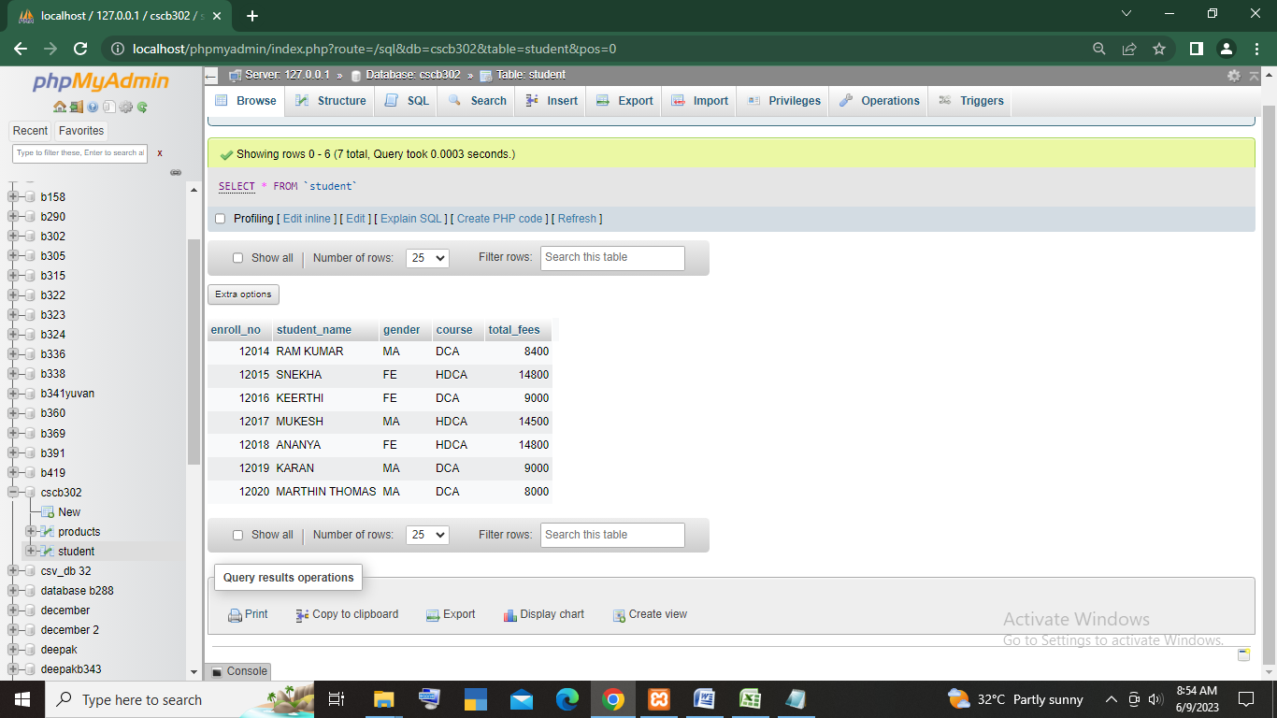***Ans: UPDATE student SET student_name = "SNEKHA" WHERE enroll_no = 12015***

***6. display all the product of price 500-2000?***

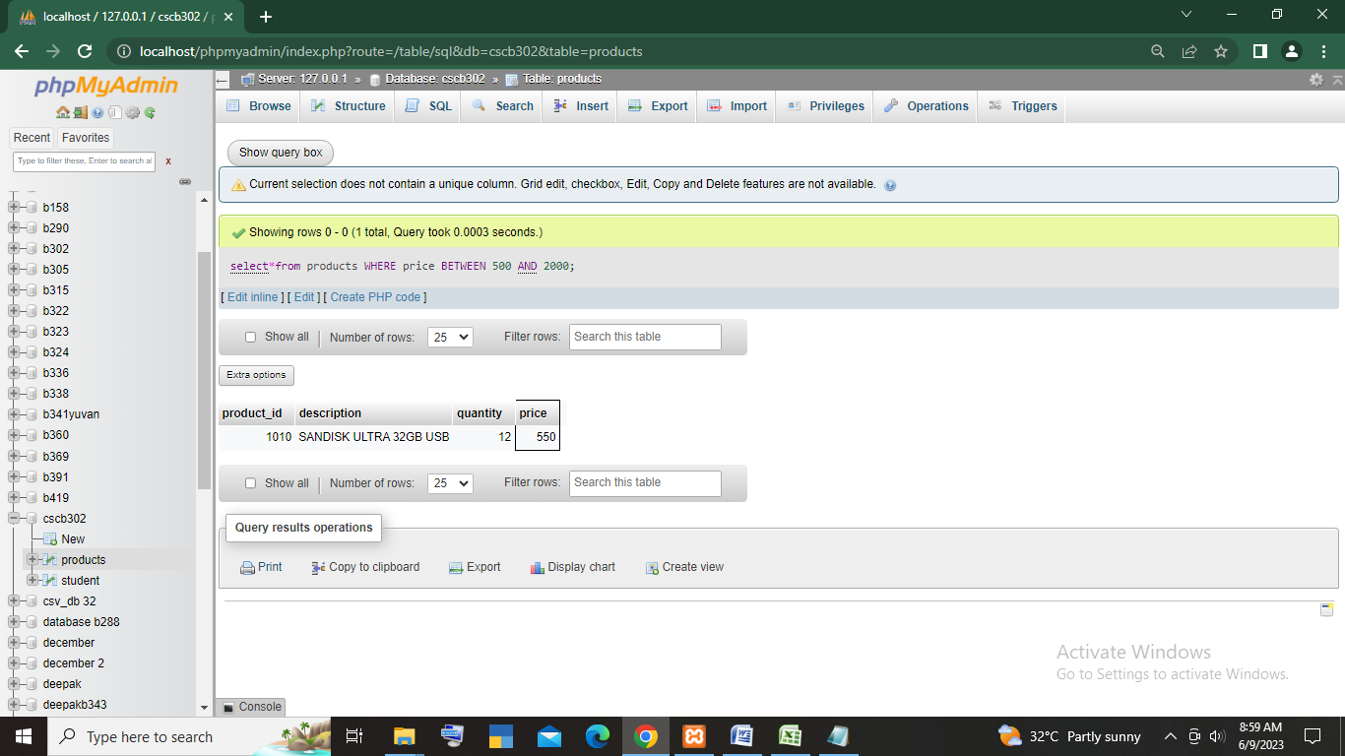***ANS:*** ***select*from products WHERE price BETWEEN 500 AND 2000***

***CREATING TABLE CUSTOMERS:***

***create table customers(***

***customerid int unsigned ,***

***customername varchar(30),***

***mobileno BIGINT(10),***

***area varchar(20)***

***)***

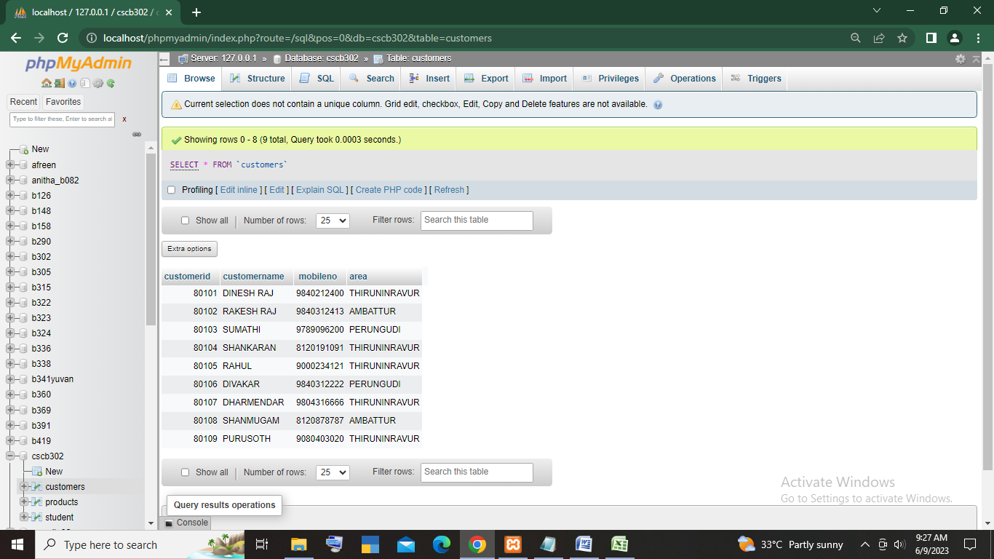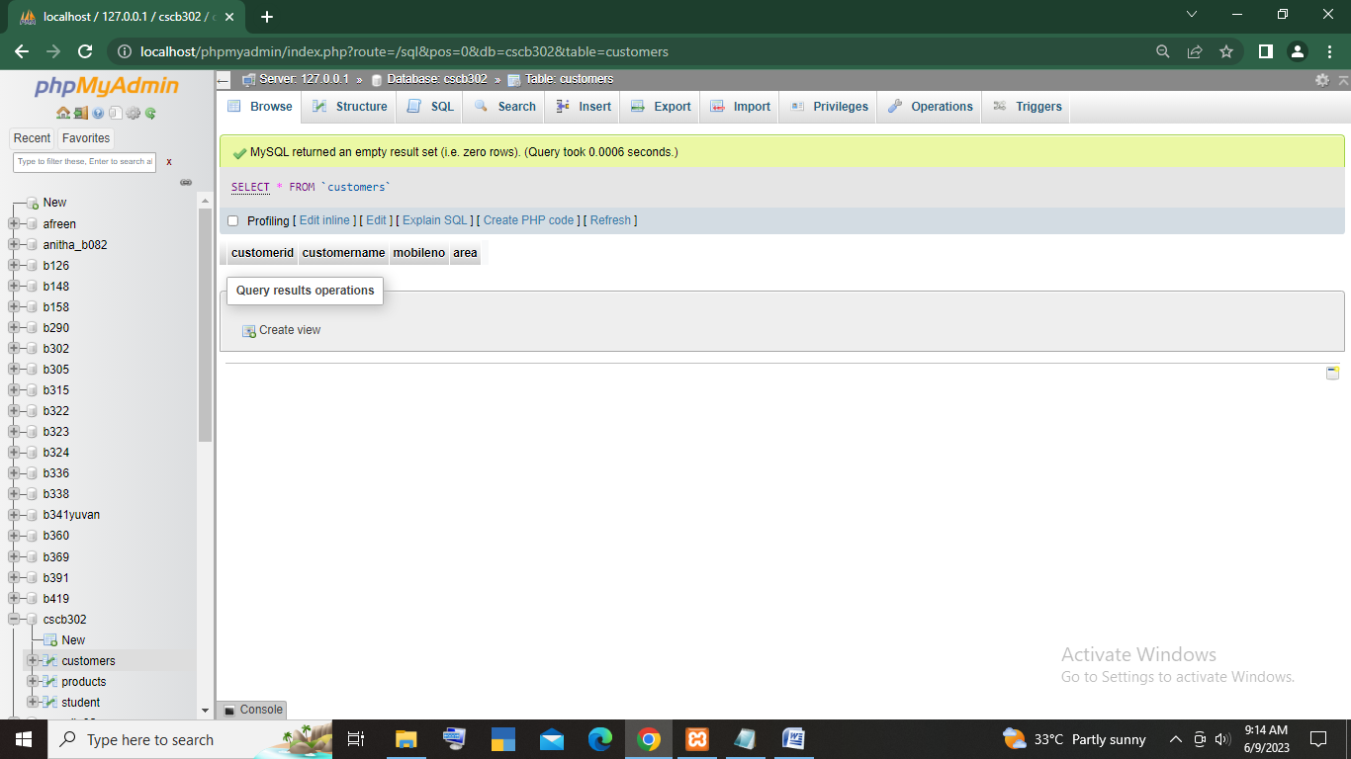***after importing the values:***

***QUESTIONS:***

***1.DISPLAY ALL AREAS WHERE THE CUSTOMER IS LIVING?***

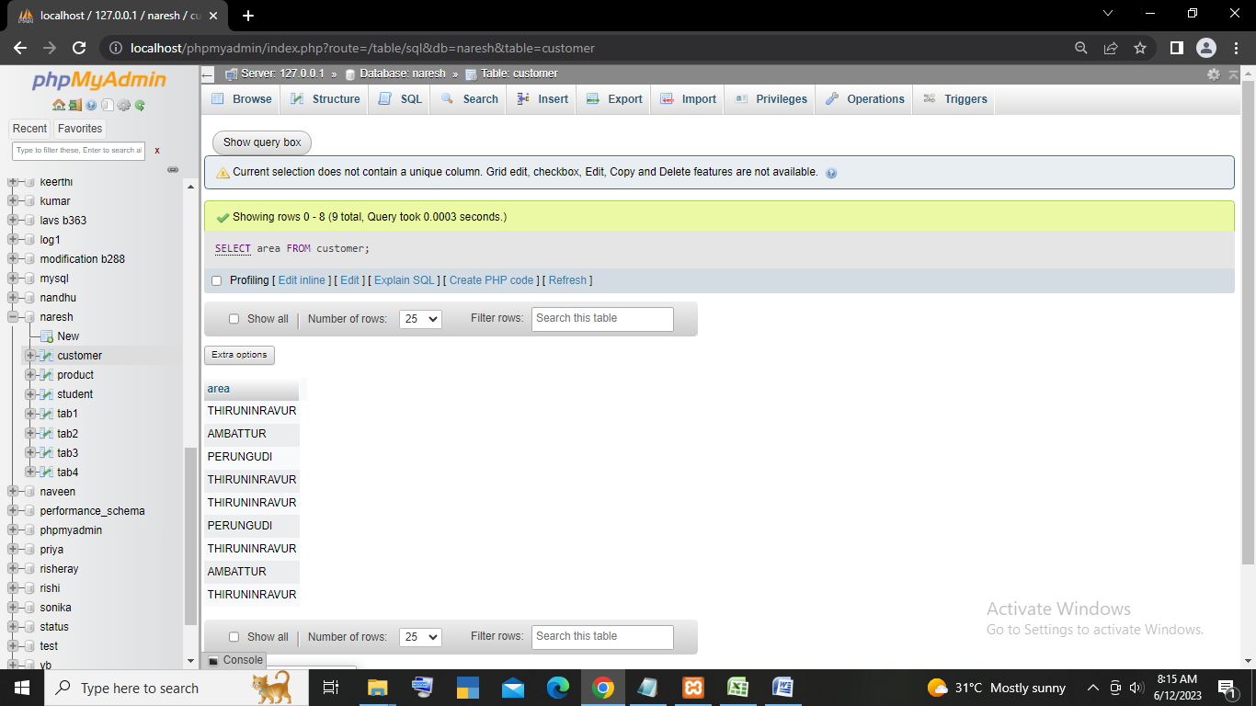

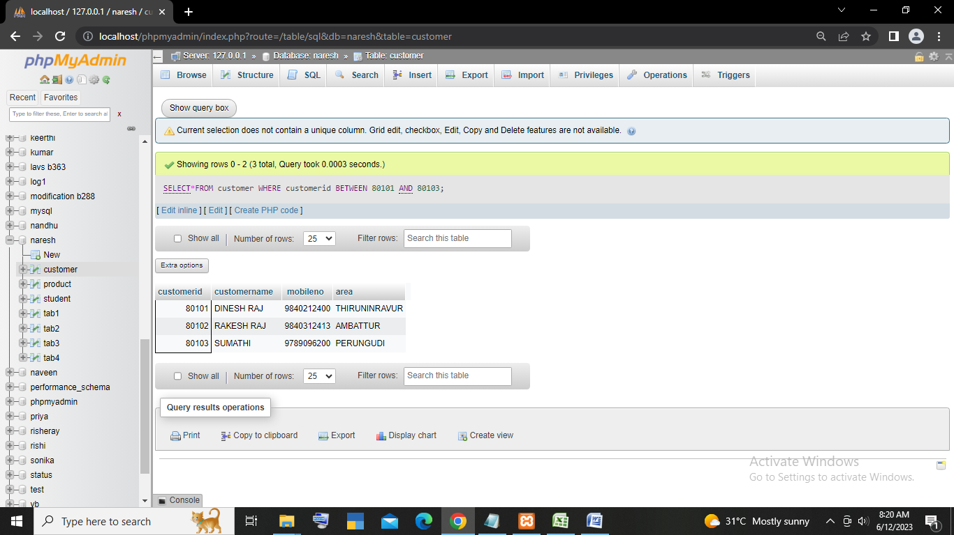***2.DISPLAY THE FIRST 3 ROWS IN CUSTOMER TABLE?***

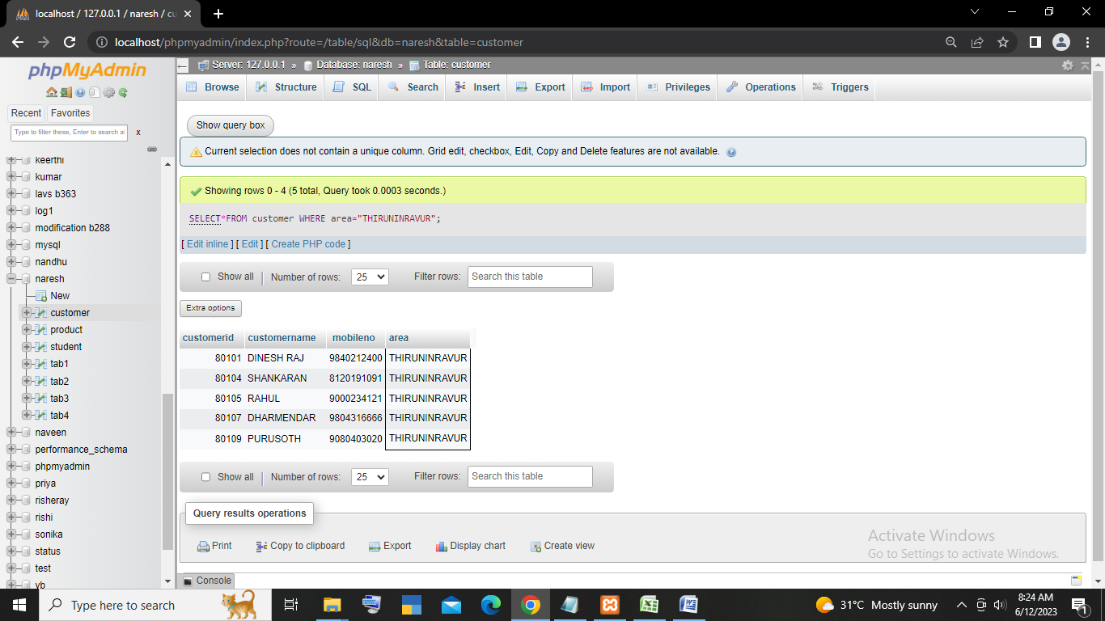***3.DISPLAY ALL THE CUSTOMERS WHO WERE LIVING IN THIRUNINRAVUR?***

***4.DISPLAY ALL THE CUSTOMERS BY ARRANGEING THEIR NAME IN DESENDING ORDER?***

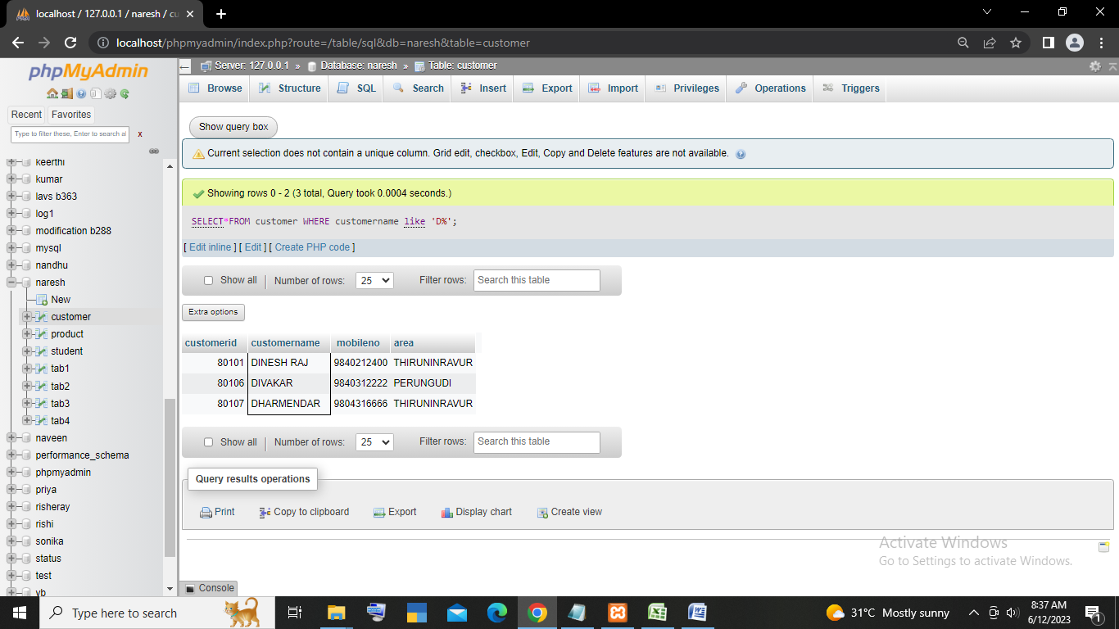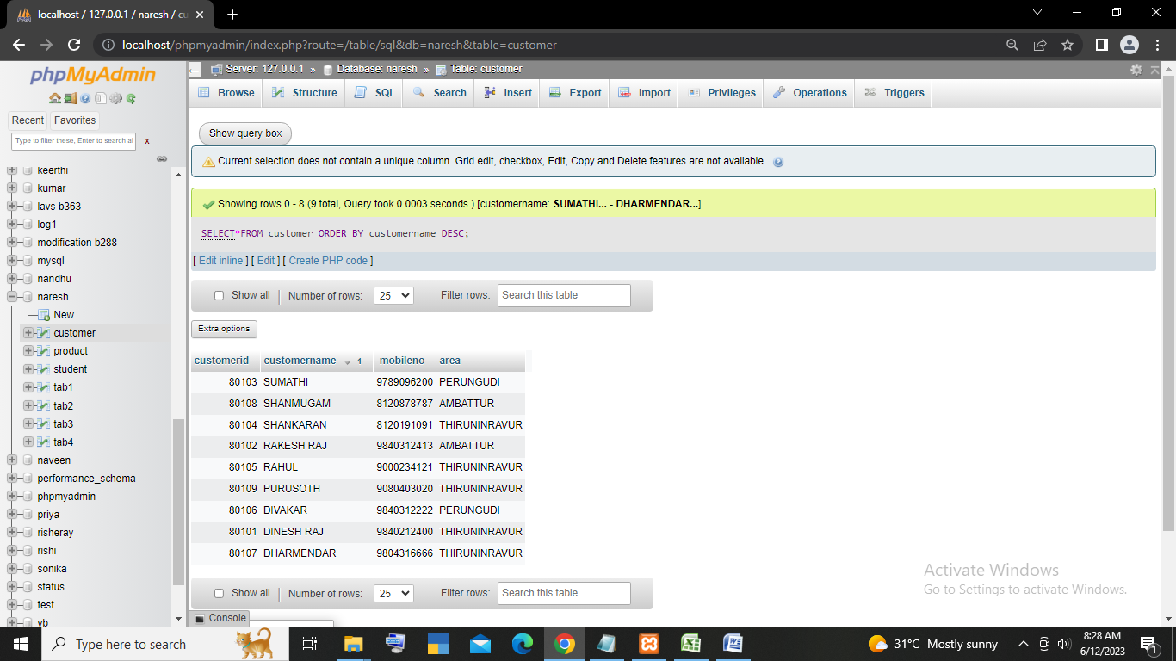***5.DISPLAY ALL THE CUSTOMERS WHOSE NAME STARTS BY’D’?***

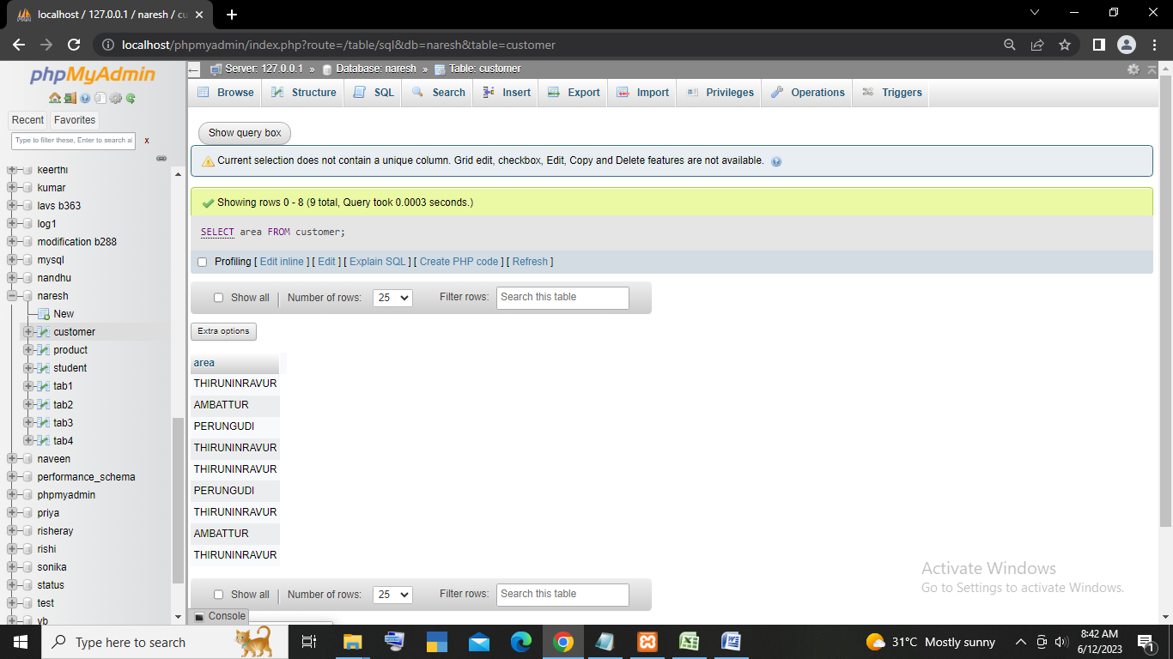***6.FIND OUT THE AREA OF ALL CUSTOMERS THOSE ID GREATER THAN 80109?***

***7.display all the customers by arranging their name ,area wise?***

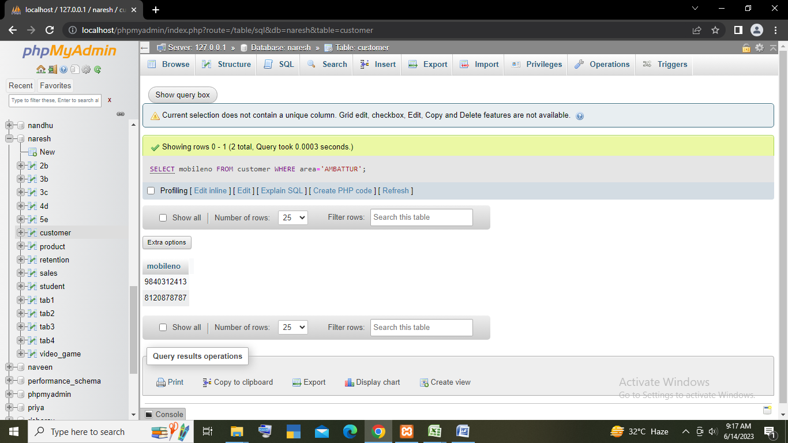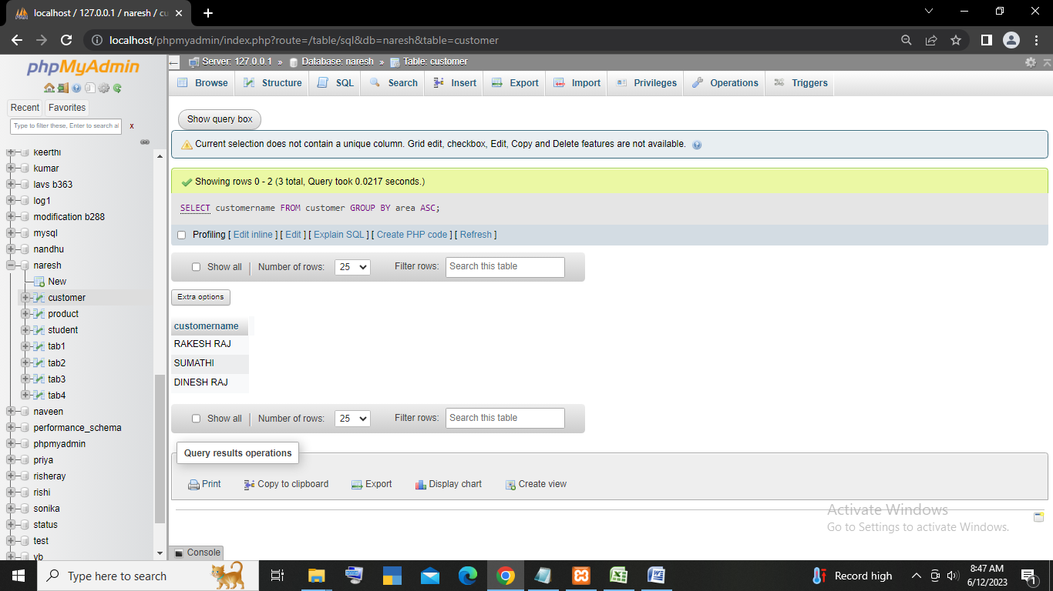***8.DISPLAY MOBILE NUMBERS OF THE CUSTOMERS IN AMBATTUR, PERUNGUDI?***

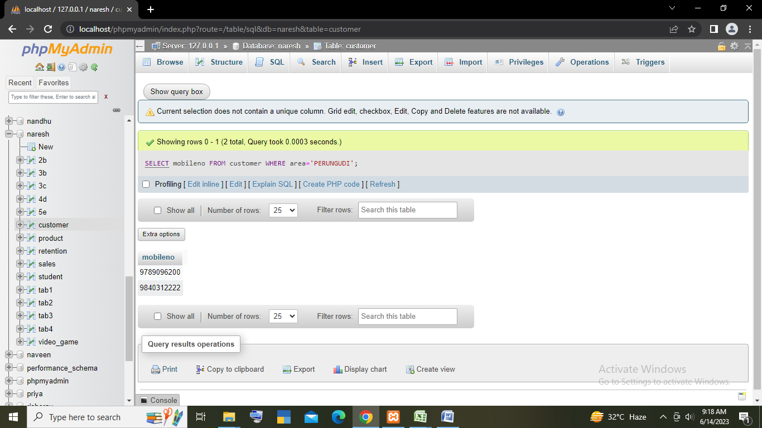

***9.DISPLAY ALL THE CUSTOMERS OF NAME ENDS WITH ‘RAJ’?***

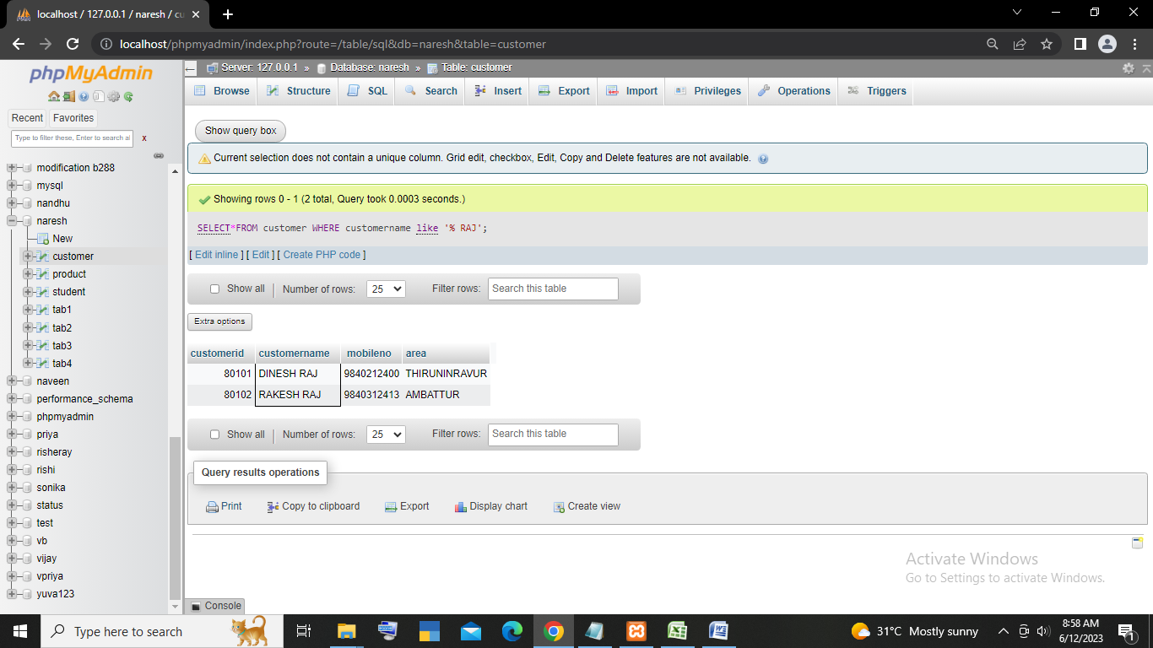

***Importing retention table:***

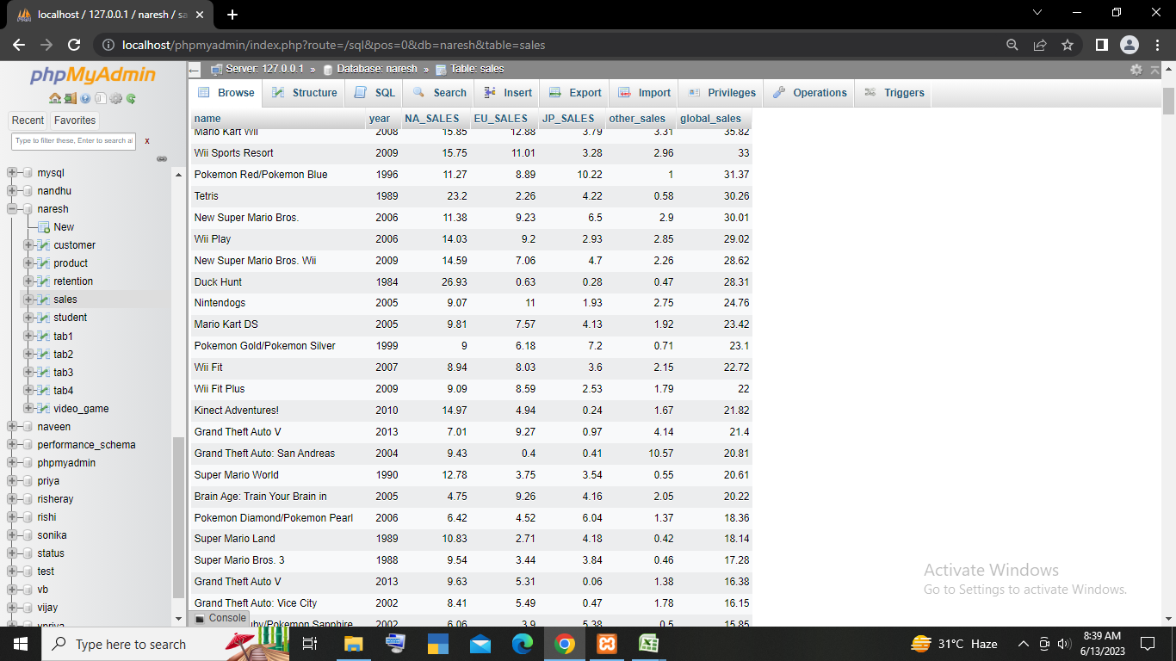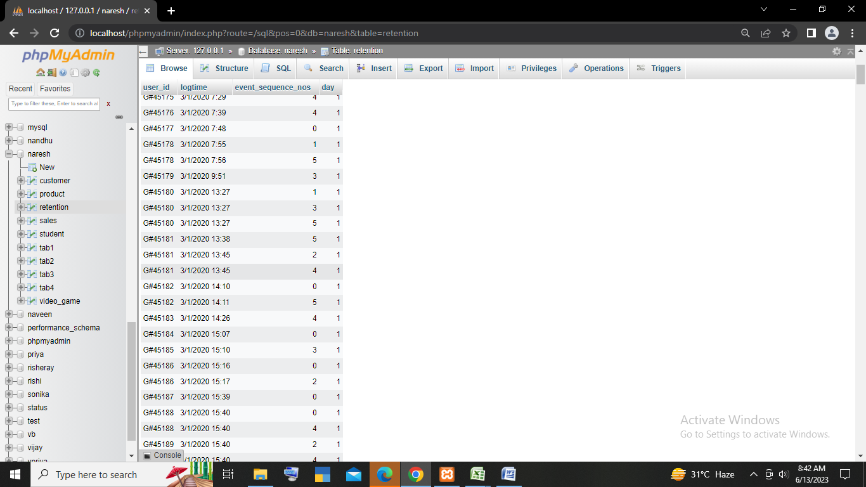***importing sales table:***

***importing video games table:***

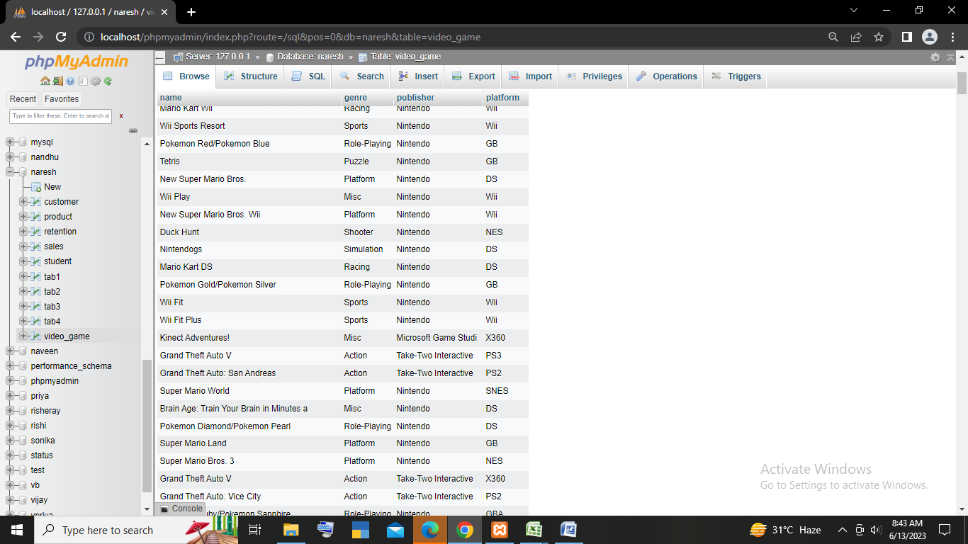***Case study:***

***ans:***

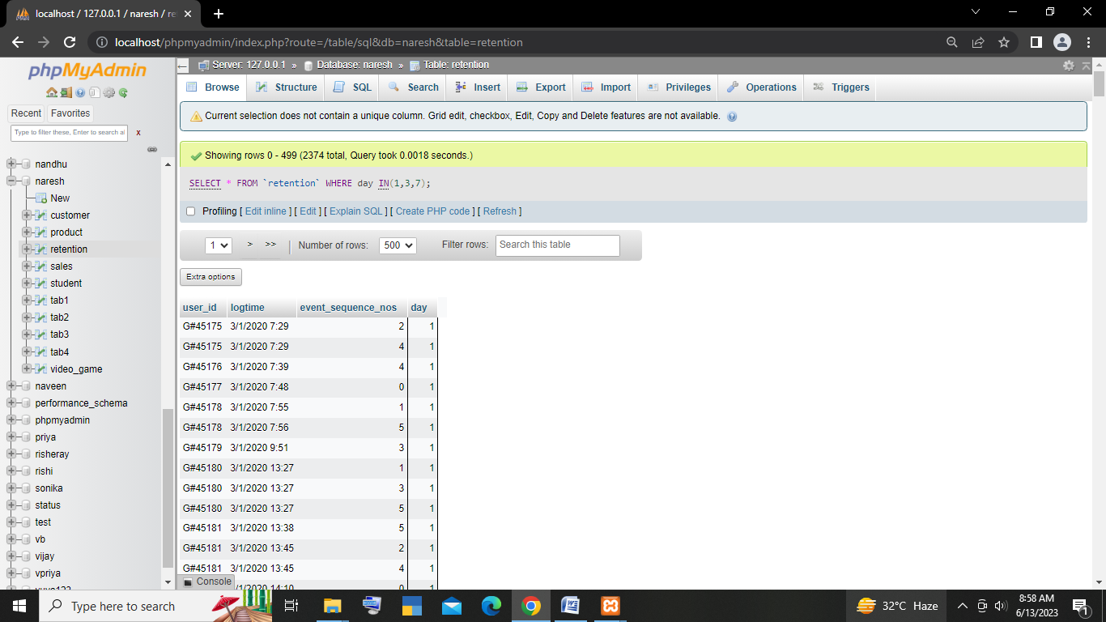***a.)***

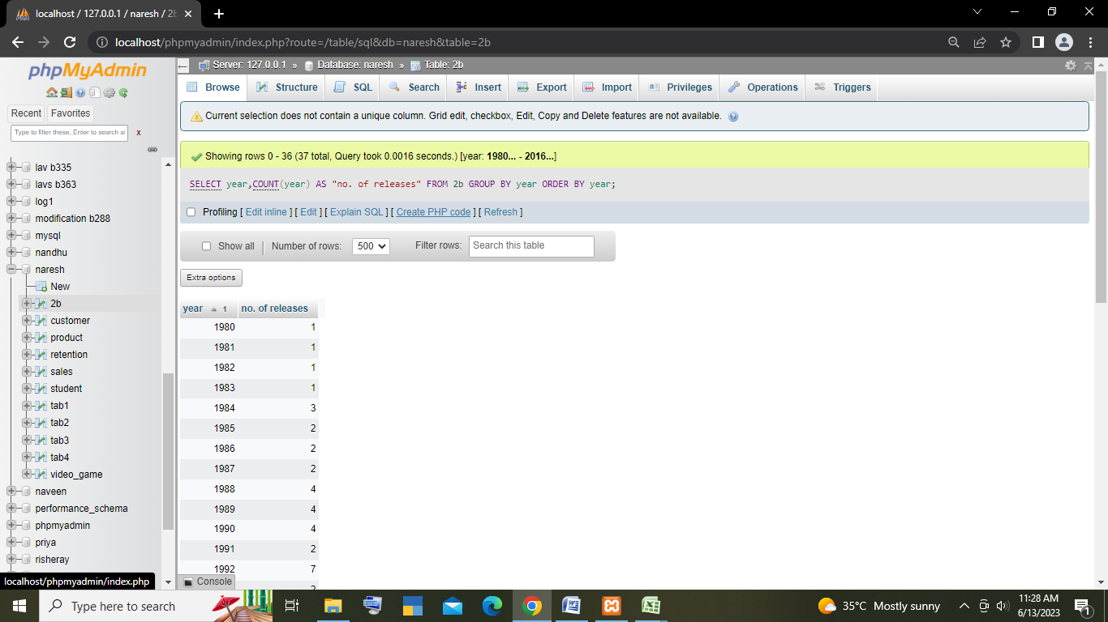***2b.)***

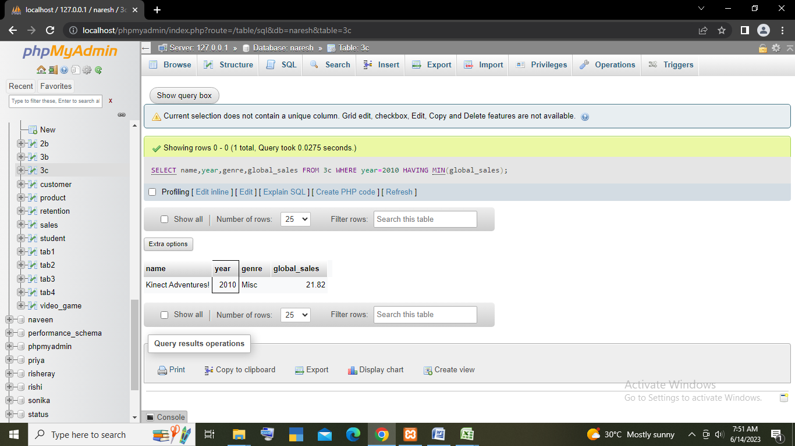***3c.)***

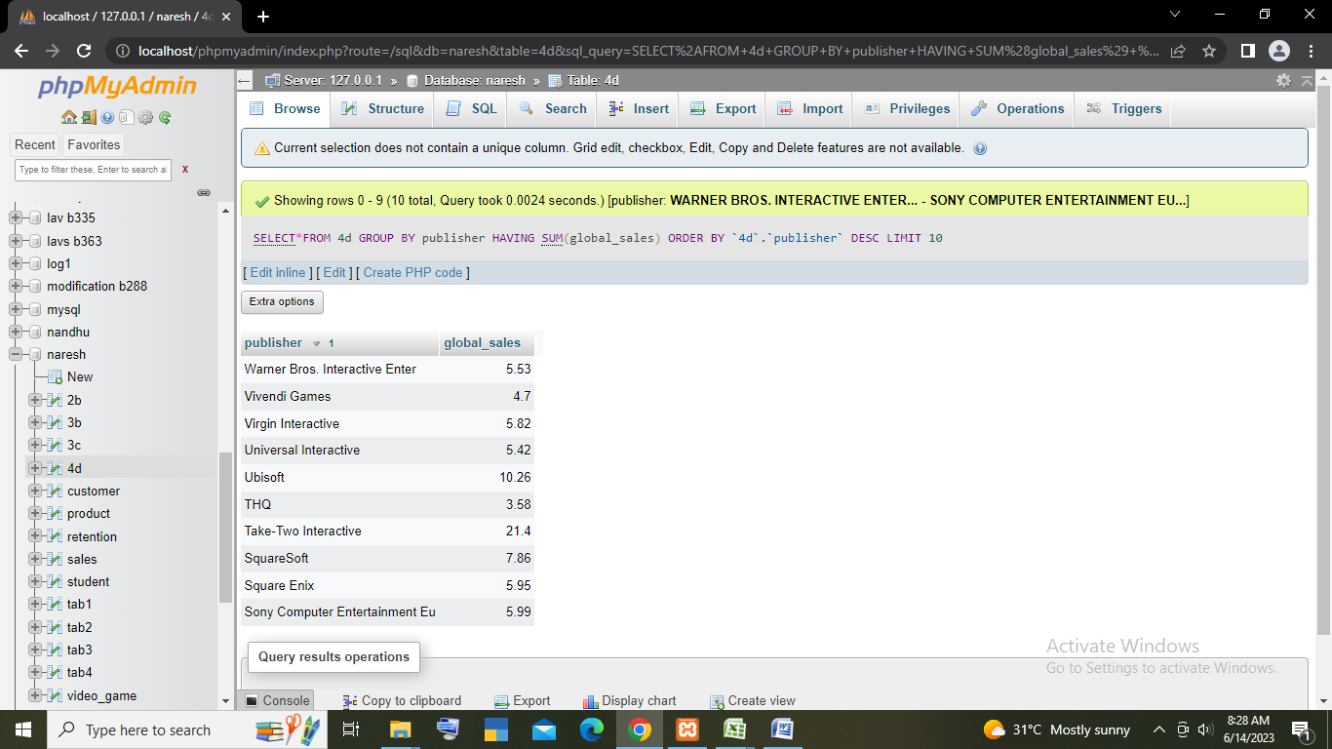***4d.)***

***5e.)***

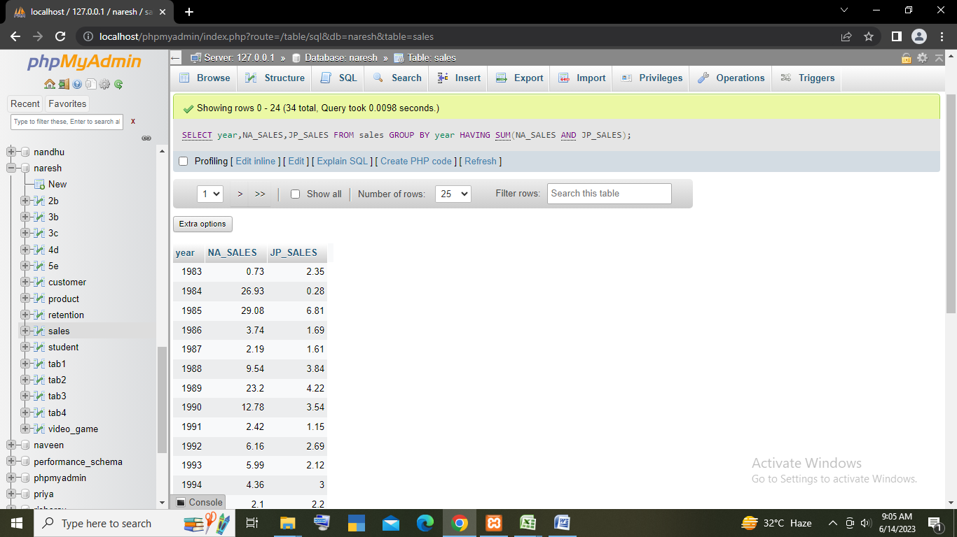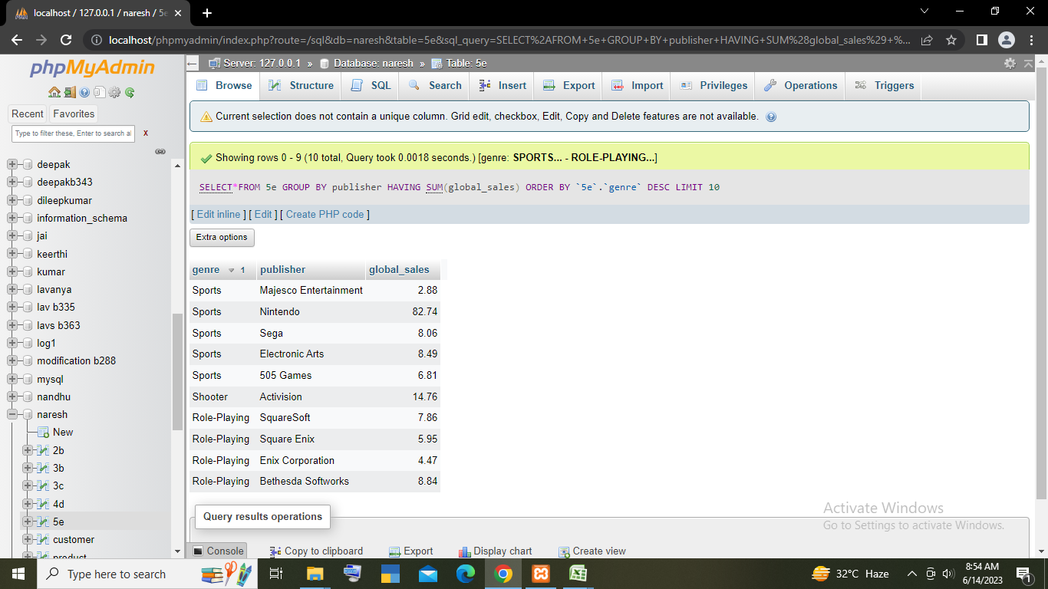***6f.)***